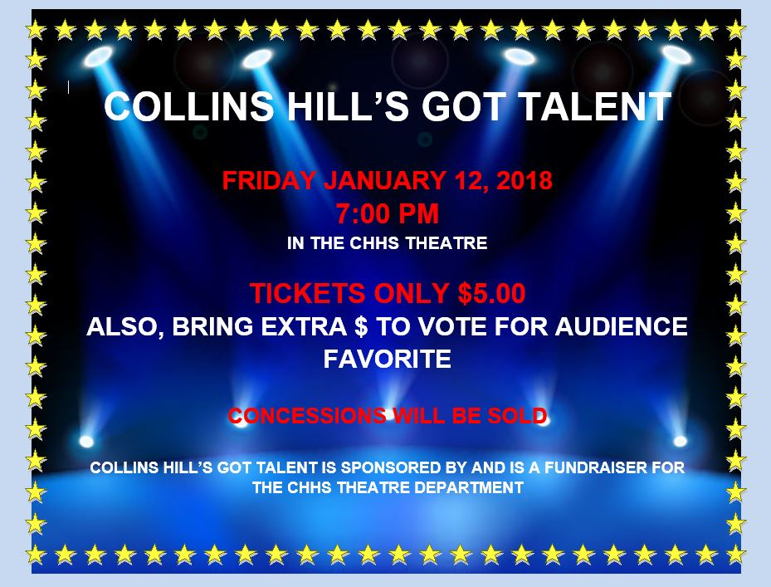
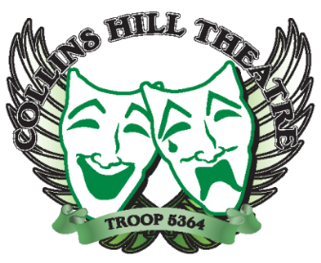
Collins Hill’s Got Talent
2018 Performers
(In no particular order)

Shane Brown & Tre’ Wyatt
Ashlee Lynch
Esther Kim
Giselle Escobar
Lauryn Shealy
Molly Thomas
Jonah Harmon
Corbin Jones & Foxx Clark
Maddie Ross
Christa Campbell
Justice Johnigan & Aim Laccruche
Cedrick Ambeau
Maya Jumpp
Marya Bekhit
Emily Munoz
Marie Jordan & Kasey Miller
Angel Kulig
Mahlon Phillips
Mikayla Dudley
Madeline Demos & Noelle McIntyre
Jordan Blackwell
Jalen Major
Mia Roxbury

Congratulations!!
All performers and emcees are required to attend a mandatory FULL DRESS rehearsal on Thursday, January 11 from 2:30 – 5:30 p.m. in the CHHS Theatre. If you do not attend, you will be removed from the show. You must wear your performance attire and have everything you need for the actual show. Please select outfits that are school and performance appropriate. If your act requires a music track, send your iTunes-compatible music file to our Stage Manager, Hannah Holland (hannahholland402@yahoo.com) by Monday, January 8th. All singing tracks must be a KARAOKE version if you are singing without an instrument. All lyrics must be school-appropriate. And, PLEASE MEMORIZE all lyrics/lines – phones and scripts will not be allowed on stage.

