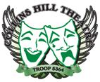
WHEN THAT HELL BOMB FALLS

WRITTEN-DIRECTED BY BRUCE M. BOIGNER
Presented By:
CHOCOLATE-FROSTED SUGAR BOMBS
And
HACKENKOPH CIGARETTE COMPANY

CAST LIST:

WILHELM VAN BEERS Daniel Hanberry
MARIAH VAN BEERS Julia Whitten
CLARISE VAN BEERS Madeline Demos
MARKUS SCHAAL Eric Lora
DOOMSDAY RADIO ANNOUNCER Lafayette Bussey

