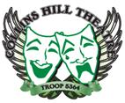
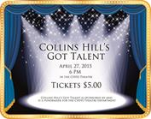
Collins Hill’s Got Talent!
Sponsored by the CHHS Theatre program
Your hosts: Mrs. Margaret Cheeley and Elizabeth Tobar

Act I:

- Josie Gill and Niye Asemota
- Spencer Ross
- Destiny Sampmles
- Massiel Nunez
- Daisie Akkasha, Meagan Bojarski, Olivia Eafano, Alyssa Ivon, Alli Pierre, Julia Whitten
- Nasia Gladmon
- Alberto Andrade and Emma Huys
- Kristen Jeffy

10-minute Intermission
Enjoy concessions in the Commons Area. Also, be sure to use any spare change (or bills) to vote for the FAN FAVORITE! All proceeds benefit the Drama Boosters.

Act II:

- Sophie Cardot
- Summer Clarke-Davis
- Olivia Eafano and Avrie Hollis
- Gabe Haynes
- Dominique Viard and Celine Ellis
- Taylor Knott
- Imani Bailye, Aysha Jackson, Alyse Watson

10-minute Intermission for judges to deliberate

Winner announcements

- First place – Alberto Andrade and Emma Huys
- Second place – Sophie Cardot
- Third place – Nasia Gladmon
- Fan Favorite – Daisie Akkasha, Meagan Bojarski, Olivia Eafano, Alyssa Ivon, Alli Pierre, Julia Whitten

Thank you to our performers, judges, hosts, volunteers and audience for supporting the CHHS Theatre program and making this show so successful.

